Healthy Behavior Change E-Guide Home Page

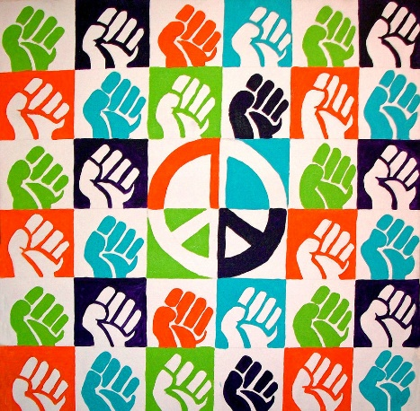
What is the Healthy Behavior Change E-Guide?
Power to the People: This Healthy Behavior Change E-Guide pulls together information on the research and practice that describe the Real Revolution in health care – the empowerment of people, families and communities to take charge of their health.
The E-Guide is our attempt to:
- Bring the focus of health back to the individual, family and community.
- Connect silos of the excellent Healthy Behavior Change work that is currently underway.
- Curate important content to help people begin an exploration of areas that may be unfamiliar to them.

ABOUT PAGE

Who is the Audience for the Healthy Behavior Change E-Guide?
This E-Guide has been designed for current and emerging leaders who are interested in moving beyond the current medical treatment structures in the United States where over $3 trillion dollars per year is locked up.
Leaders for a New
Health Delivery System
- Health Care Providers
- Consumer Advocates
- Public Health Officials
- Health Plan Executives
- Health Policy Experts
- Food and Nutrition Leaders
- Urban Planners
- Health System Executives
- And… (you can add to the list)
These leaders are beginning to envision and create a future where U.S. healthcare spending moves further upstream into activities that promote health and well-being and a where a balance is created between spending on “well care” and “sick care”.
As a broader group of leaders engage in this work – beyond those working in hospitals, clinics and insurance companies – they are moving beyond the four walls of the clinic, reinventing the concept of “well care” as a birth to grave, community-based set of activities and initiatives that are explored throughout this E-Guide.

Healthy Behavior Change Defined
Healthy Behavior Change is shorthand for mobilizing your internal and external resources to move toward health.
Healthy Behavior Change is shorthand for mobilizing your internal and external resources to move toward better health and well-being. It is a journey that necessarily includes getting to know yourself better and community organizing. This is because health is not only related to individual behaviors, but also environmental factors, your biology, the healthcare system, and other formal and informal systems of services and supports. The following infographic illustrates this broader picture.
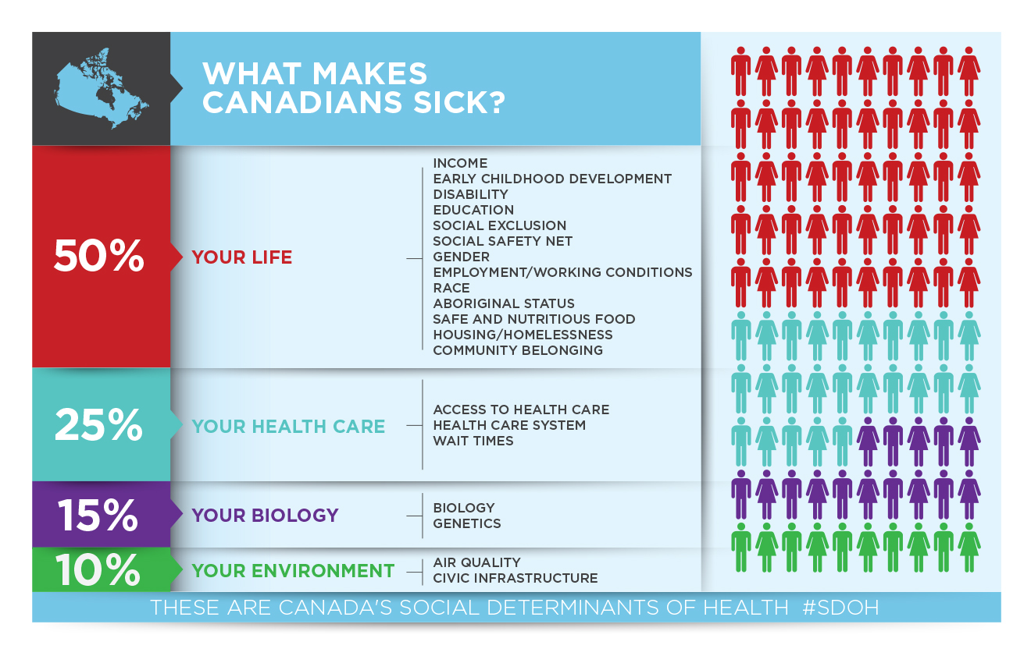
http://www.homelesshub.ca/blog/infographic-wednesday-social-determinants-health

Healthy Behavior Change E-Guide Structure
We have organized eleven areas of healthy behavior change in the following way: healthy behavior change “begins with you”, “takes a village”, and is supported by “enabling technologies”; thus the structure of this E-Guide. This E-Guide has been designed to help you begin an exploration of any or all of these areas, starting with content we have curated to support your effort.
It Begins with You

It Takes a Village | Supporting Technology

Navigating the Healthy Behavior Change E-Guide
We assume that many of you have deep expertise in one or more areas of this E-Guide. Accordingly, we have organized the E-Guide to allow you to easily navigate to any of the areas that interest you, in whatever order.
As you move into the E-Guide, you will find that each section contains the following:
- Overview of the section
- Definition of the topic
- Frameworks that describe the foundational concepts of the section
- Additional Content containing the material the authors have curated
- Other Resources to explore
- Connections to other areas
Remember, there is no beginning or end to this Healthy Behavior Change E-Guide.
Now it’s time to create your customized journey.

Why a Healthy Behavior Change E-Guide?
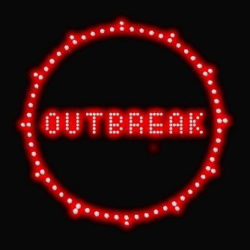
Fighting an Epidemic without a Name: We have an epidemic in the United States that has been resistant to treatment. It goes by many names. Don Berwick, the former Administrator of the federal Centers for Medicare and Medicaid, has warned us that if we don’t address it, we will “chew even more deeply into our common purse.” If we don’t solve it, “our schools will fail, our roads will fail, our competitiveness will fail. Wages will continue to lag, and, paradoxically, so will our health.”
The epidemic is manifesting itself in the form of poor health outcomes and high healthcare costs. This includes high rates of obesity, diabetes, heart disease, chronic lung disease, and disability resulting in shorter life expectancy. Person for person, healthcare in the U.S. costs twice as much as it does in the rest of the developed world.
We have been struggling to find the right name for this epidemic. It’s a complex, multi-faceted problem and every time we attempt to come up with a name we realize we’re missing major parts of the picture.
Here are a few examples.
We have an epidemic of sick care – a healthcare delivery system overly focused on illness treatment. Each year over 75% of our $3 trillion healthcare spend goes to treat chronic diseases, while we spend less than 3% of our budget on prevention. But the problem begins much further upstream before people get sick.
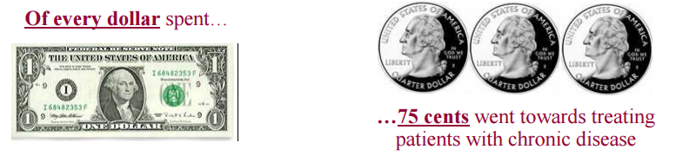
We have an epidemic of unhealthy behaviors and unfavorable lifestyles – many Americans still smoke, use alcohol excessively, are physically inactive, and have unhealthy diets. But many behaviors are connected to the communities people live in and the goods and services that are marketed to them.

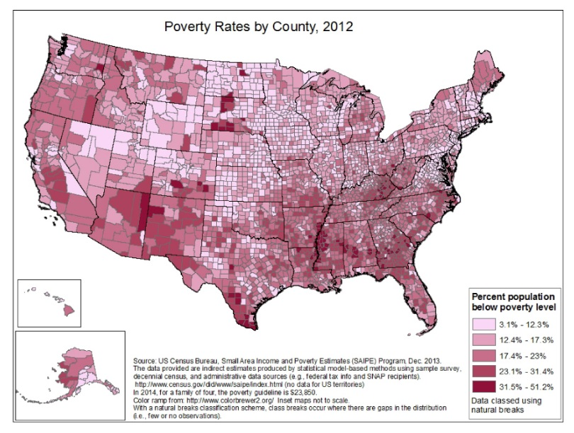
We have an epidemic of unhealthy communities – this includes poverty, high rates crime and violence, lack of access to healthy foods, underperforming schools, childhood trauma, unhealthy air and water, and more.

